**Your brain**

* 1. **Find perimeter difference of earth and circle around it in same units as provided in**

**the example.**

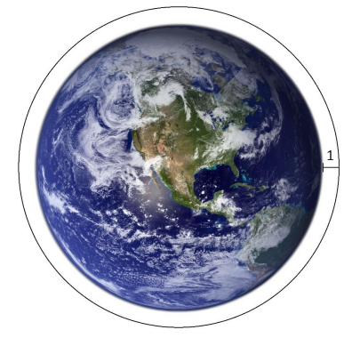

* 1. **In a survey of 75 software engineers it was found that 46 use open source and 40**

**use web technologies. Twenty of the software engineers who use open source also**

**use web technologies. Draw Venn diagram for given information.**

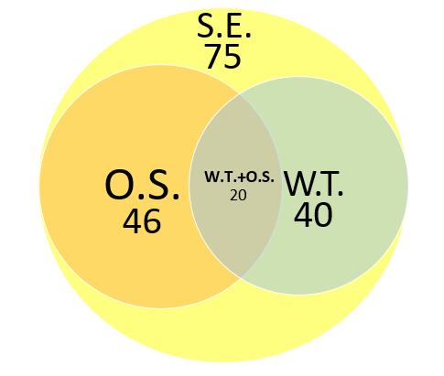

* 1. **There are 5 people (Ana, Bob, Charlie, Diana and Ebbe) working with 5 different programming languages distributed through 5 floor building. Each person use a unique language and works in different floor. Please fill in table below from conditions:**
* **Bob is working with JavaScript;**
* **Python developer is one floor beneath SQL developer;**
* **Bob works 3 floors beneath Diana;**
* **C# developer works on second floor;**
* **Java developer is 3 floors above Ana;**
* **Ebbe does not know Python programming language.**

|  |  |  |  |  |  |
| --- | --- | --- | --- | --- | --- |
|  | **Ana** | **Bob** | **Charlie** | **Diana** | **Ebbe** |
| **Language** | **C#** | **Javascript** | **Python** | **SQL** | **Java** |
| **Floor** | **2** | **1** | **3** | **4** | **5** |